https://www.microsoft.com/en-us/research/people/?from=http%3A%2F%2Fresearch.microsoft.com%2Fen-us%2Fum%2Fpeople%2Fkahe%2F

Summary:

【数据库】ILSVRC 2014 Detection

消除CNN对于固定输入的图片的要求，SPP-NET

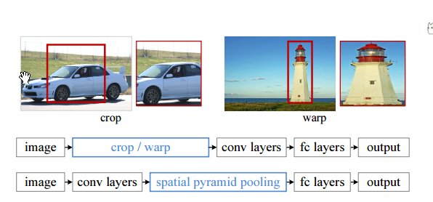

SPP 的优点：

1) SPP is able to generate a fixedlength output regardless of the input size, while the sliding window pooling used in the previous deep networks [3] cannot;

2) SPP uses multi-level spatial bins, while the sliding window pooling uses only a single window size.

减少对于CNN的要求；增加对于目标检测的好处

【Feature maps】即CNN的输出！！！

【Bag-Of-Words】The global pooling operation corresponds to the traditional Bag-of-Words method.

【经典网络】ZF-5与OverFeat

【疑惑术语点】single-sized， multi-scale features(S=?)

The main purpose of our multi-size training is to simulate the varying input sizes while still leveraging the existing well-optimized fixed-size implementations.【算是对技术的妥协】

-------------------------------先无脑的读一下把。。

混淆概念：multiple scales, multiple views

在目标检测方面：

SPP有1-sacale与5-scale版本

使用不同的初始值训练出两个不同的网络，然后评判得分

Dectation与classification数据库之间的区别：

1. 前者的数据量与数据类要比后者小得多
2. 两者的image-scale不同，前者大概0.5，而后者为0.8

买沐浴露；买指甲刀